Want to get to know Israel from the inside? Live for 10 months with Israelis, speak Hebrew, and take part in this once in a life time experience? If so, **Nachshon is the program for you**!

**Nachshon- the Israeli Mechina**, is a program that gives participants from overseas the opportunity to be immersed in a completely Israeli environment while traveling, volunteering and learning with their Israeli peers. What is unique about this program is that it was originally created to give young Israelis the chance to devote a year to social leadership and change. And for its 19th year (and counting), the program has opened its doors to Jewish gap year students (post high-school) from around the world to join in the program with their Israeli peers.

**How is the program structured? Is there academic credit?**

You learn about yourself and the country through experiencing it. While learning different subjects in and out of the classroom such as leadership, Zionism , Jewish identity and topics that specifically interest the participants. You travel through Israel, get to know the land and cultures within Israeli society. The program also includes countless hikes, a week of army experience (Gadna), “survival” week, themed weeks exploring Israeli society in depth, organizing a week long camp for young kids at risk, and many more unforgettable life experiences. One of the vital parts of this year is weekly voluntary work done throughout the country during throughout the year.

Nachshon is a pluralistic program, and opens its doors to the leading educators and participants from all religious and ideological streams. The objective of the program is personal enrichment through experiential learning and community building, and therefore it does not provide an academic framework or academic credit. For a year, participants are encouraged to learn for the sake of learning without grades, tests or the pressure of school. One of the most enticing aspects of Nachshon is the participant's ability to guide their own educational experiences. Participants as a group build their schedule, plan their treks/hikes around Israel, invite their chosen lecturers, and take responsibility for the success of the program.

**What exactly is a Social Leadership Program and a “Mechina”?**

The program is based on the constant emphasis of leadership. The active role that participants have in their experiences sets the program apart from others. Nachshon participants govern the program with the assistance of experienced instructors which includes establishing the group community standards, planning trips, tours, volunteer projects, social events and almost every aspect of the program.

Mechina (which literally means preparation), is a growing phenomenon in Israel in the last decade. Initiated by caring Israeli citizens aiming to develop social leadership in Israel, the Mechina programs offer Israeli high-school graduates the opportunity to defer their compulsory army service by a year and spend the year engaged in study, travel and community building. Nachshon was the first Mechina program of its kind to open its doors 19 years ago, more than thousand Israelis choose this unique opportunity for personal enrichment every year though one of the Mechinot across Israel. While the Israeli participants are preparing for their army service, we see great value that the participants from abroad can gain from the leadership experience even though they are not obligated to join the army.

**What is the general profile of participants in this program?**

Nachshon generally attracts two types of overseas participants:

1)     **Children of Israelis:** Many of the participants are children of one or two Israeli living overseas. On one hand, they feel very connected to Israel, and that typical “touristy” programs are not right for them. On the other hand, having grown up outside of Israel, they might not feel confident being on their own, and are looking for a supportive social framework. Nachshon is the perfect balance for them. They are living with Israeli peers and speaking Hebrew, yet they have an accompanying staff, a warm social community, and the opportunity to expand their knowledge of Israeli history and society.

2)     **Day-School graduates, or graduates high-school Israel programs looking for a more authentic Israeli experience:** Many of the day school students or other Jewishly-involved students have been to Israel numerous times before they graduate. Therefore participating in another tourist program can be repetitive for them. Nachshon gives graduates who feel a strong connection to Israel, and have done other programs, a different, more authentic Israel experience.

**How many participants are there each year?**

Nachshon participants live in one of three locations in the Northern Negev. Each location has about 50-60 participants, some of them are overseas participants.

**What language is the program conducted in? Is all programming common with the Israeli participants?**

The program is conducted entirely in Hebrew, and therefore all participants must have a Hebrew background. There is no separate programming for the overseas participants. They are an integral part of the Nachshon community, and participate in all aspects of the program with the Israelis.

**How much does the program cost?**

The program cost for the 2016-2017 year is: $13,500 (Including $1000 registration fee). All participants are entitled for 500$ Masa funding. You can also apply for an additional scholarship from Masa.

The program cost covers housing, all meals, medical insurance and all educational programming and trips.

**For more information, please visit:** **www.m-nachshon.org** **or contact us at:** [**office@m-nachshon.org**](mailto:office@m-nachshon.org) or call 972.52.8345.388

[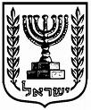](http://www.israelbar.org.il/UploadImages/israel_state_logo2.jpg)[](http://www.lajewishpages.com/organizations/yellow_images/1185210645_logo_blue.JPG)[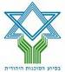](http://kupa.gemeljazo.org.il/GemelWeb/images/body/morelinks/10_sochnut1.jpg)

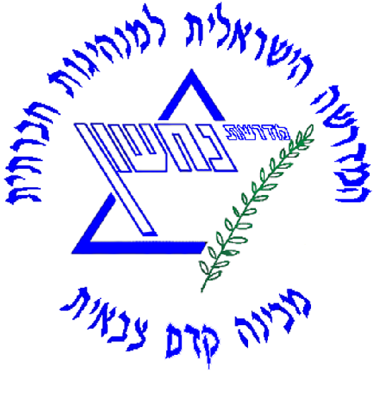

[http://tbn0.google.com/images?q=tbn:sBhxJPU1GKMtqM:http://www.israelnewsagency.com/MasaHeaderPic_English.jpg](http://www.israelnewsagency.com/MasaHeaderPic_English.jpg)

**For more information, please email**

[nachshonisrael13@gmail.com](mailto:nachshonisrael13@gmail.com) **or visit: www.m-nachshon.org**

